Tableau Project

Dataset 1: <https://www.kaggle.com/rajanand/suicides-in-india>

Question 1: Find total number of suicides in each state of India.

Result:

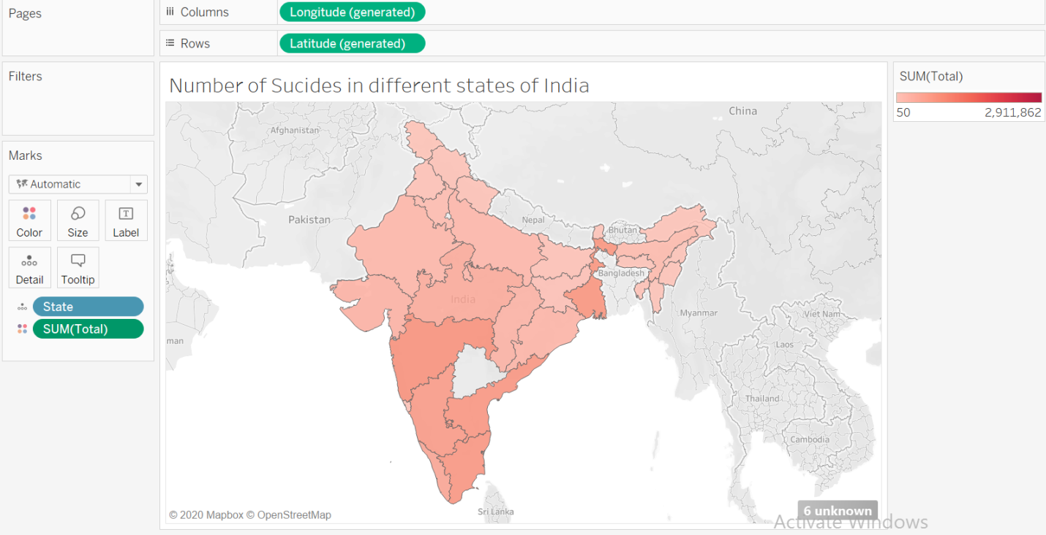

Question 2: Find the number of suicides in different age groups categorized by gender.

Result:

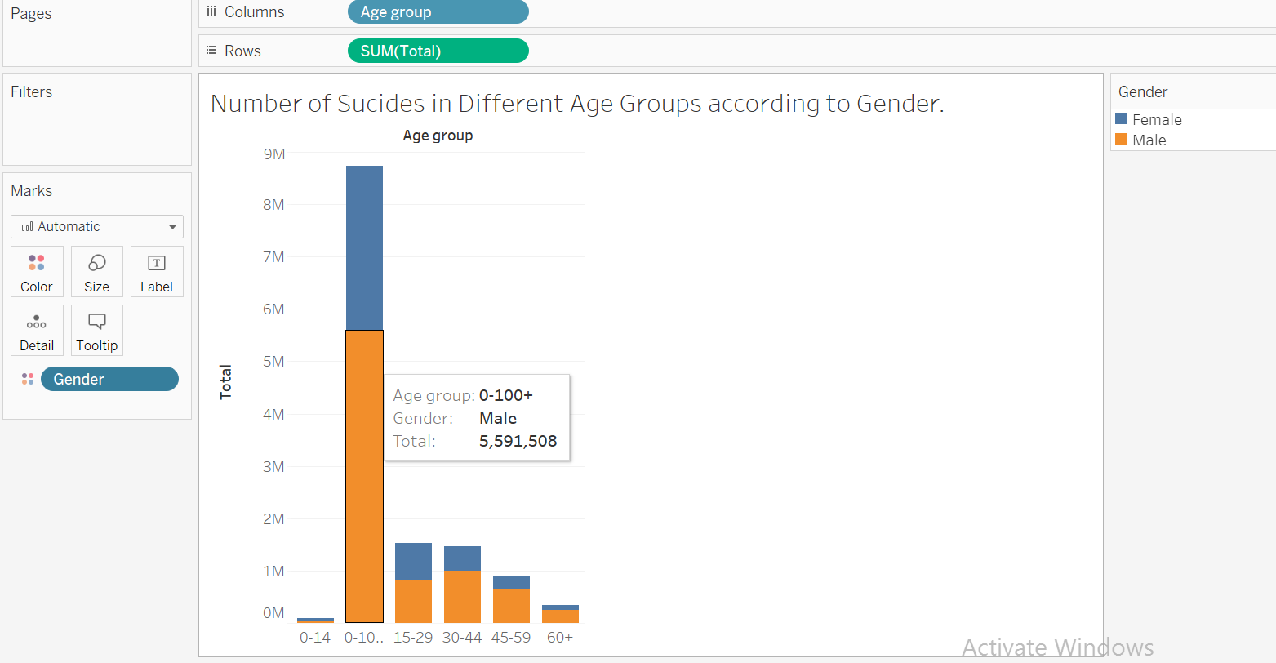

Question 3: Find the number of suicides attempted by different type.

Result:

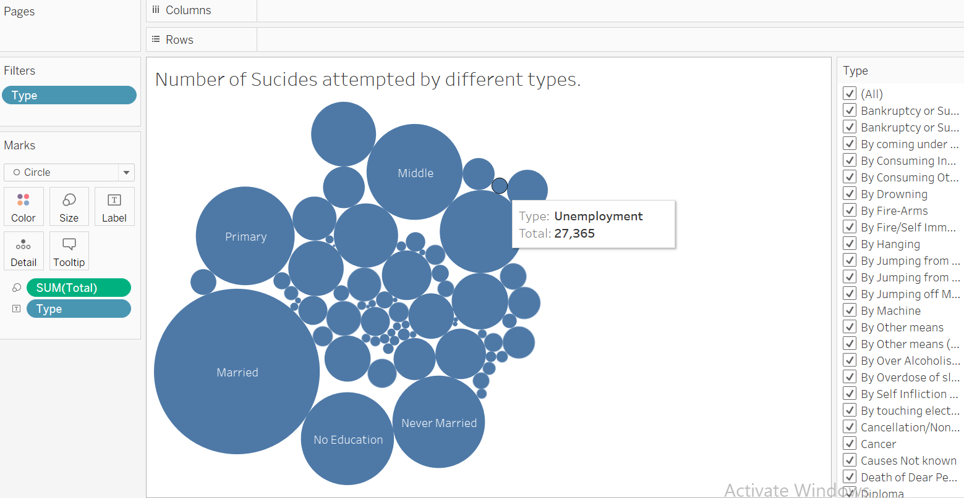

Question 4: Find the number of suicides in different years categorized by gender.

Result:

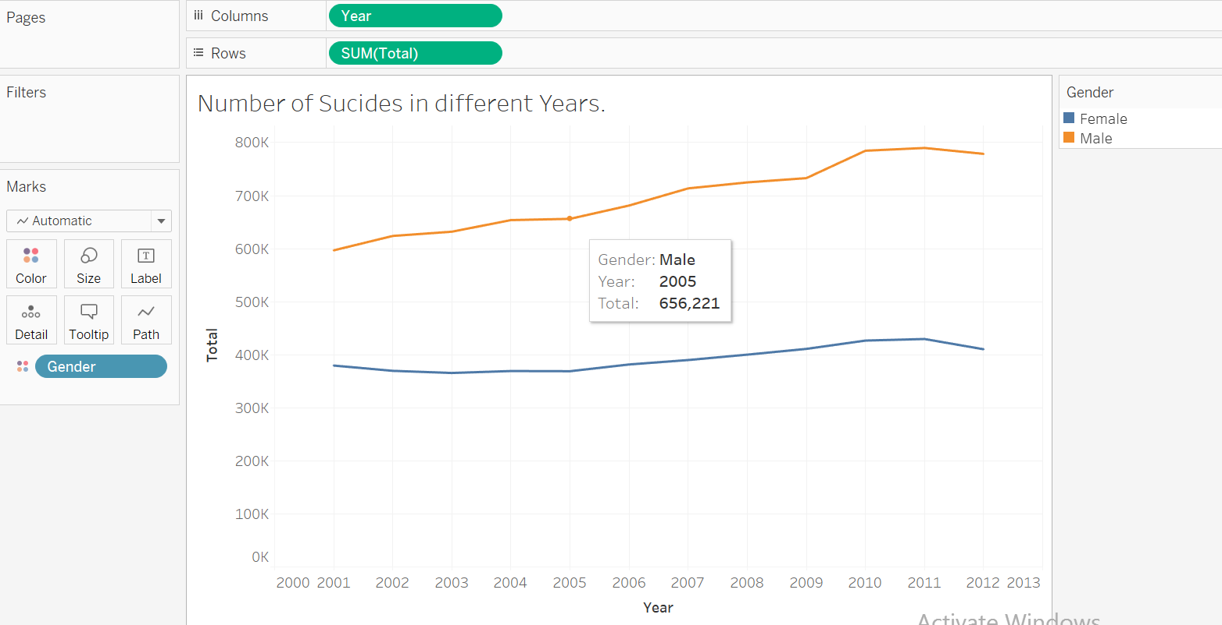

Dashboard 1:

